**Assignment 2**

Image stitching



**Omar Salah Abdelkader 6809**

**Aly Mohamed Ali 6835**

**Youssef Yosry Mohamed 6953**

**1.1 Getting Correspondences**

In order to establish reliable correspondence between the two images, we implemented a manual approach to pinpoint distinctive points in both views. We placed red circles around these key correspondences in both the left and right images. The selected points were chosen with precision to ensure accuracy in subsequent calculations for the homography matrix. By visually representing these correspondences with red circles in both images, we have effectively created a reliable set of data points for calculating the homography matrix.

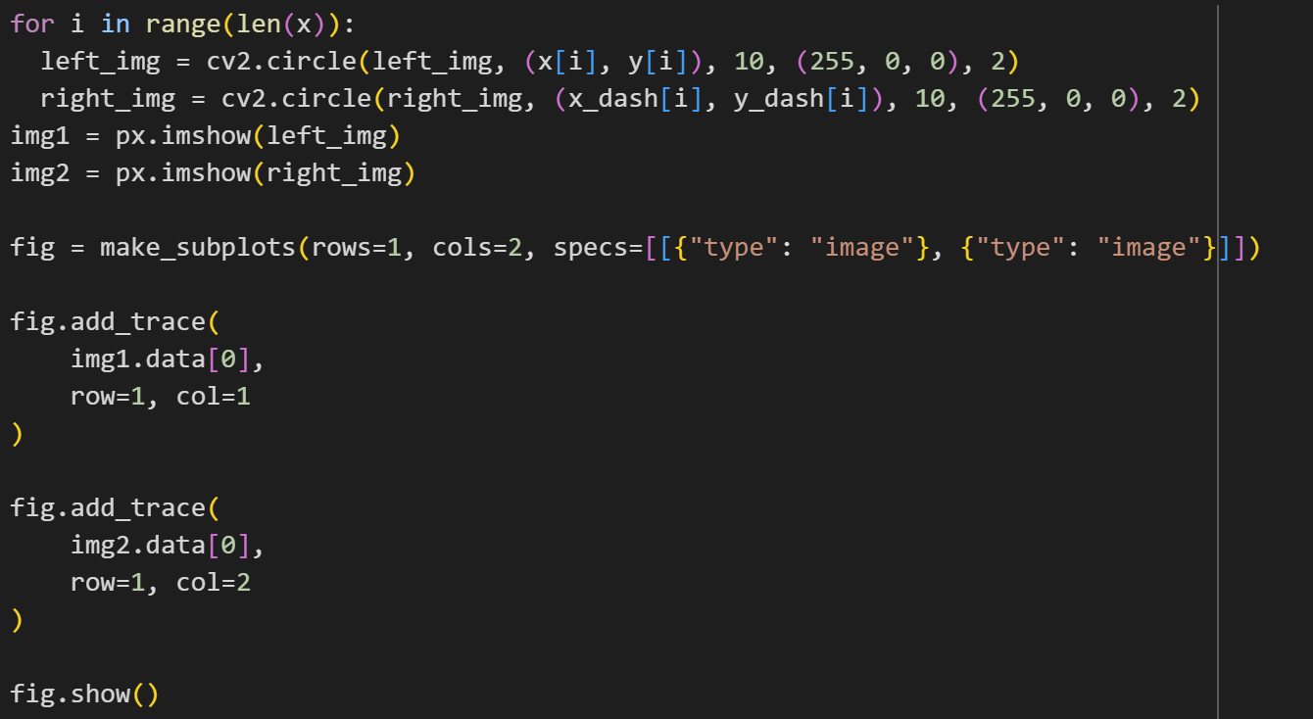

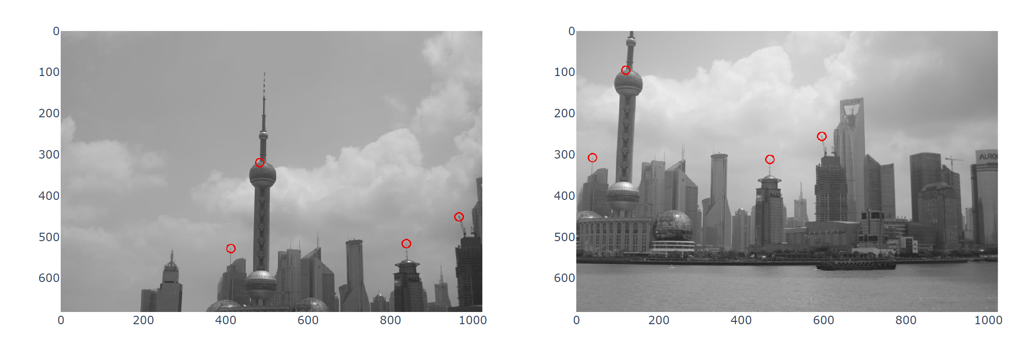

**1.2 Compute the Homography Parameters**

We implemented a function to compute the 3x3 homography matrix, denoted as H, which does the transformation of points from one view to their corresponding homogeneous coordinates in the second view. To achieve this, we devised a solution based on a system of linear equations, where the unknowns of the homography matrix H are stacked into an 8-vector x.

Our 'make_A' function constructs the matrix A using the provided sets of corresponding image points. The resulting matrix A is then utilized in the 'calculate_H' function, which employs the Singular Value Decomposition (SVD) method. This technique extracts the unknown homography matrix parameters by decomposing matrix A into its constituent parts: U, S, and Vt. The homography matrix H is then derived from the last row of Vt, reshaped into a 3x3 matrix, and normalized by dividing by its element H[2, 2].

To validate the accuracy of our computed homography matrix, we mapped the clicked image points from one view to the other using the calculated H. These transformed points were then superimposed on their respective images, providing a visual verification of the correctness of our solution.

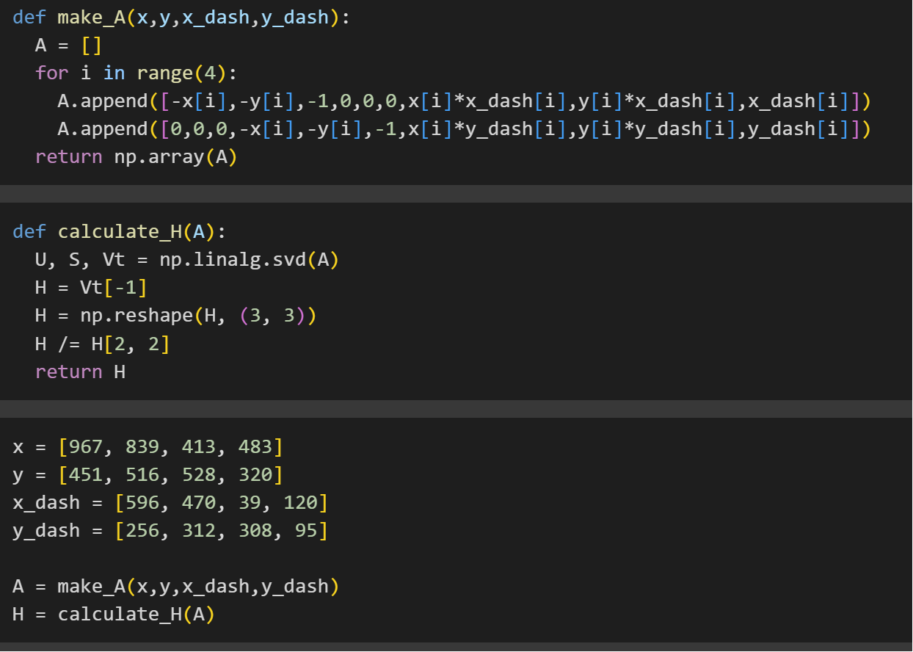

**1.3 Warping Between Image Planes and 1.4 Create the output mosaic**

**calculate_coordinates(H, img)**

This function calculates the height and width of the bounding box in the new reference frame after applying the homography matrix **H** to the given image **img**. It does so by transforming the corner coordinates of the image and computing the dimensions based on the transformed positions.

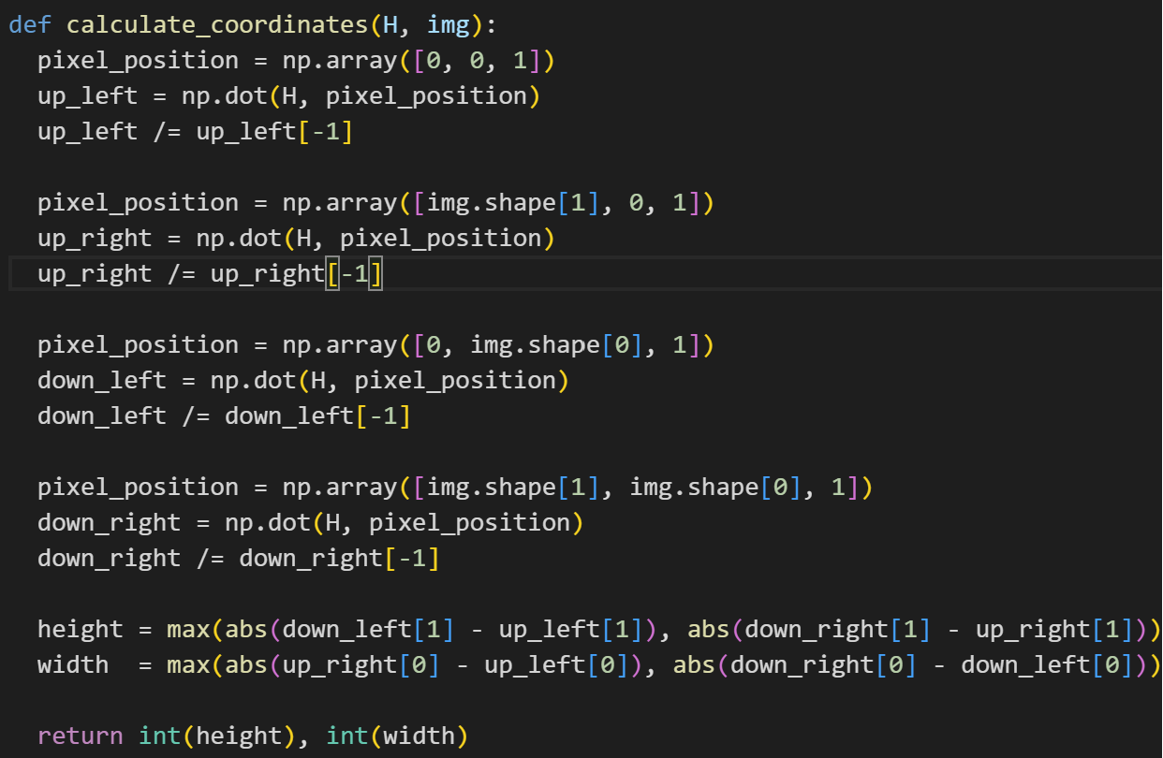

**warp(H, stitched_image, img)**

The warp function takes a homography matrix H, a stitched image stitched_image, and an input image img. It performs a forward warp, transforming the pixels from the input image to the stitched image according to the homography matrix. The function iterates through each pixel in the input image, applies the homography transformation, and updates the corresponding pixel in the stitched image.

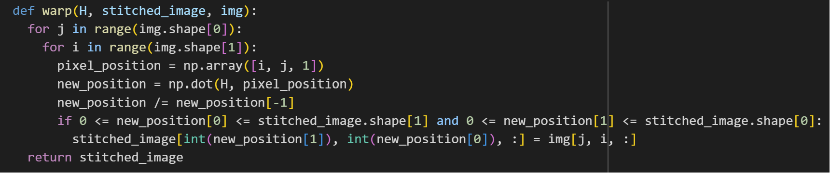

**forward_warp(H, new_img, img, offset1=0, offset2=0)**

Similar to the previous function, forward_warp performs a forward warp but with the option to specify offsets. It transforms the pixels from the input image img to a new image new_img based on the homography matrix H. The offsets are used to control the starting position in the new image.

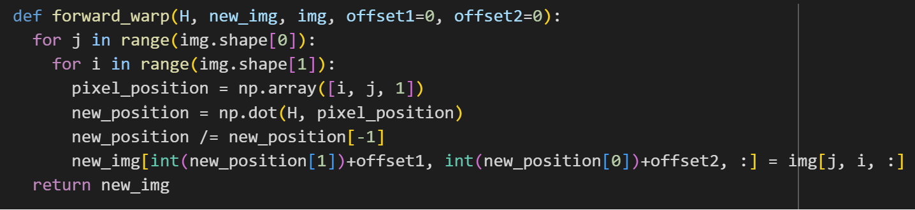

**single_inverse_warp(w, h, c, H_inv, img)**

This function performs a single inverse warp for a specific channel c at the given pixel coordinates (w, h) using the inverse homography matrix H_inv on the input image img. It calculates the pixel value at the original position by interpolating values from the nearby pixels in the source image.

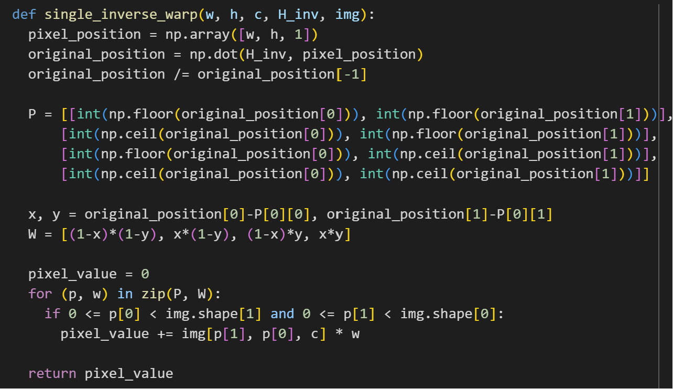

**inverse_warp(height, width, H, offset1, offset2, stitched_image, img)**

inverse_warp utilizes the inverse homography matrix H_inv to perform an inverse warp. It iterates through each pixel in the destination (stitched) image, and if the pixel is empty, it calculates the corresponding pixel value by performing inverse warping on the source image img.

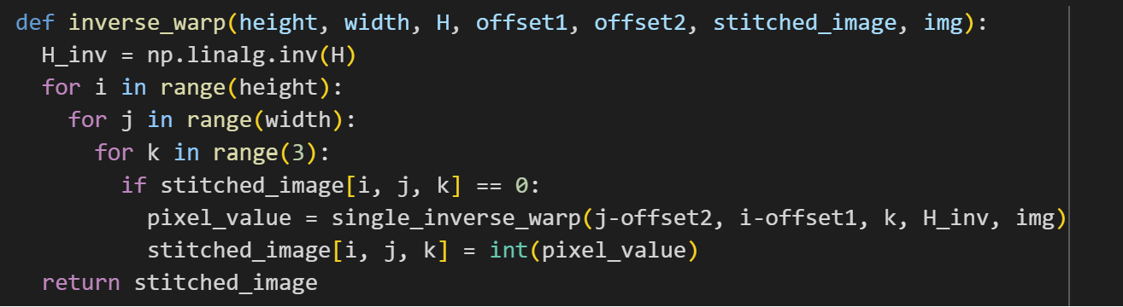

**overlay(stitched_image, img, offset1=0, offset2=0)**

The overlay function overlays the pixels from the input image img onto the stitched image stitched_image. It considers optional offsets to control the position of the overlay. If the stitched image already has a pixel value at a specific position, it retains that value.

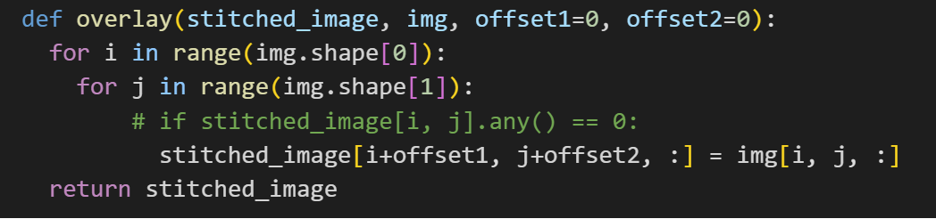

These functions collectively implement the warping and overlaying process required to create a mosaic by handling forward and inverse warping, interpolation, and pixel value updating.

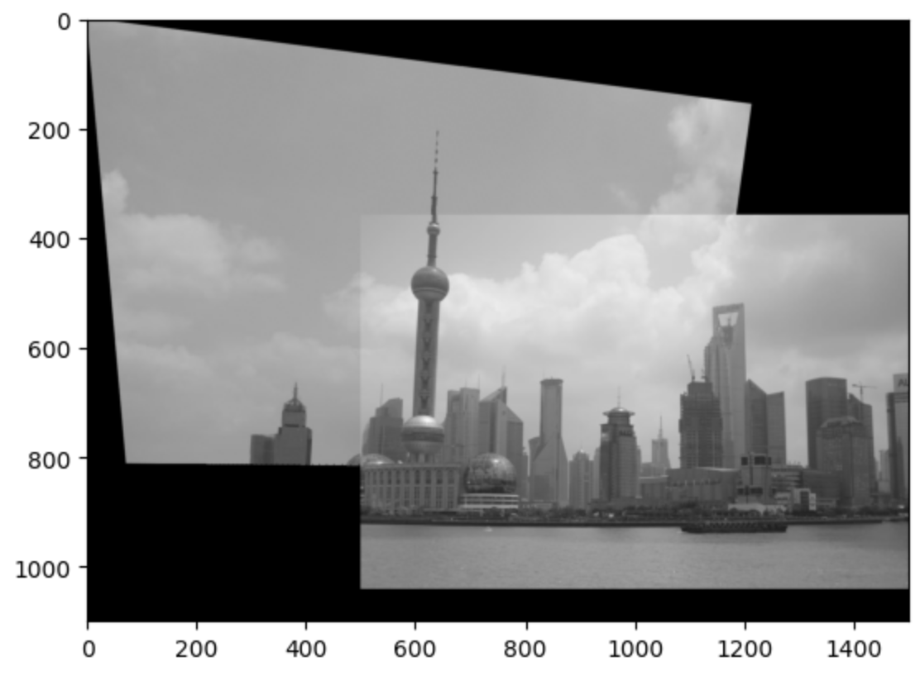

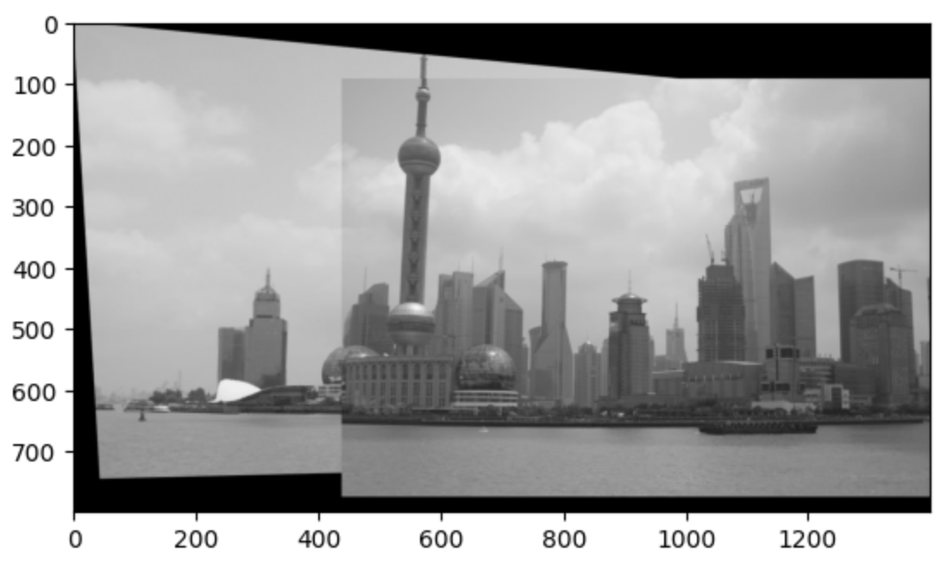

**Images from assignment PDF**

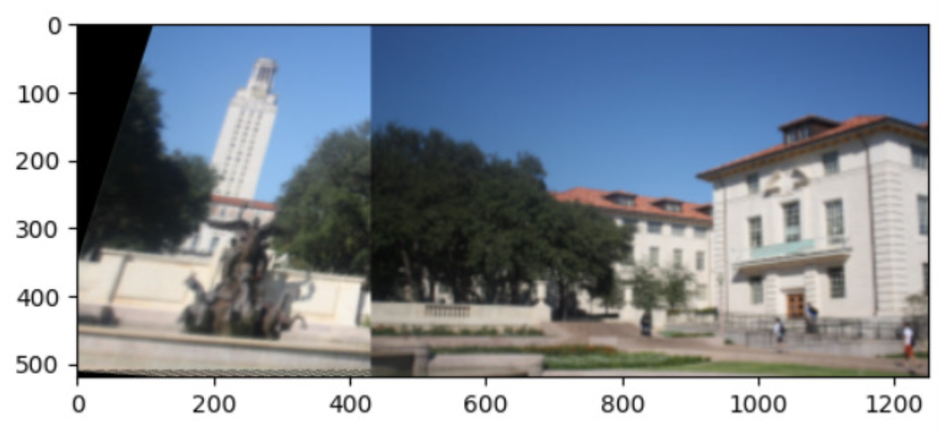

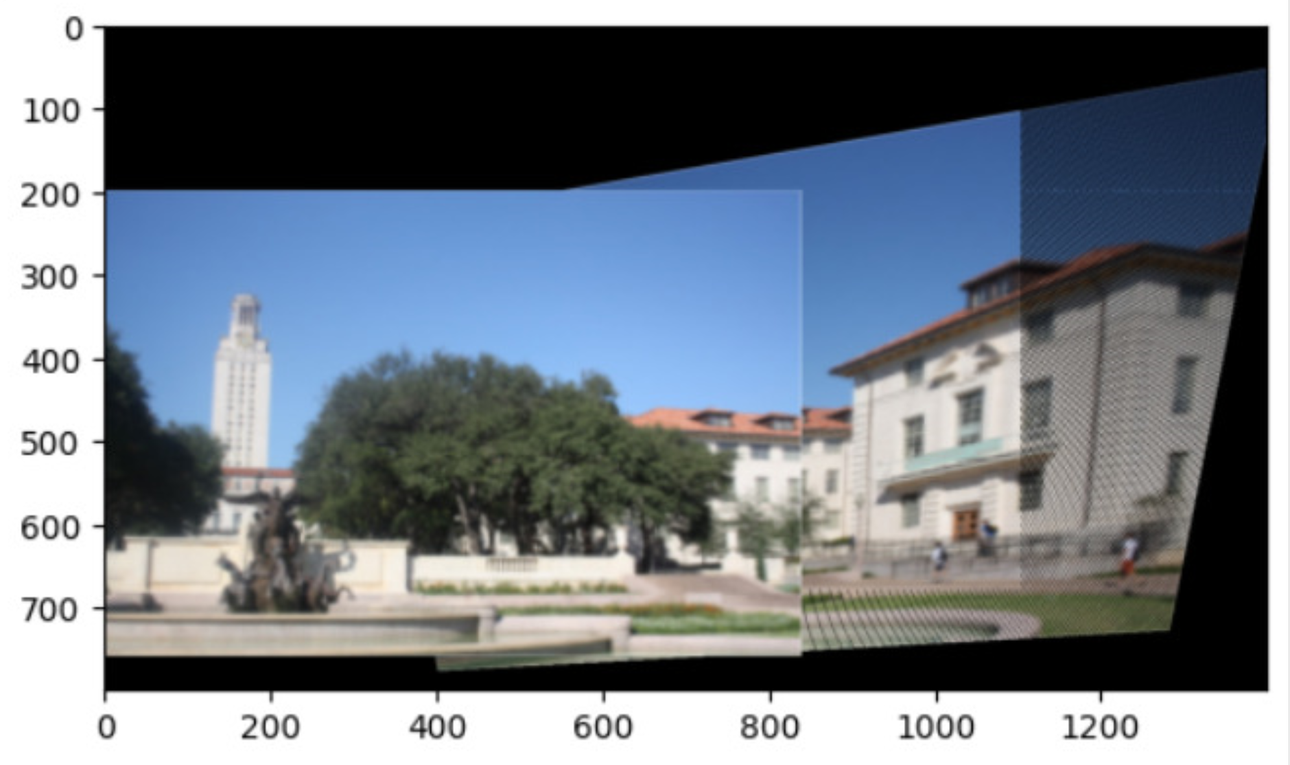

**Other Images**

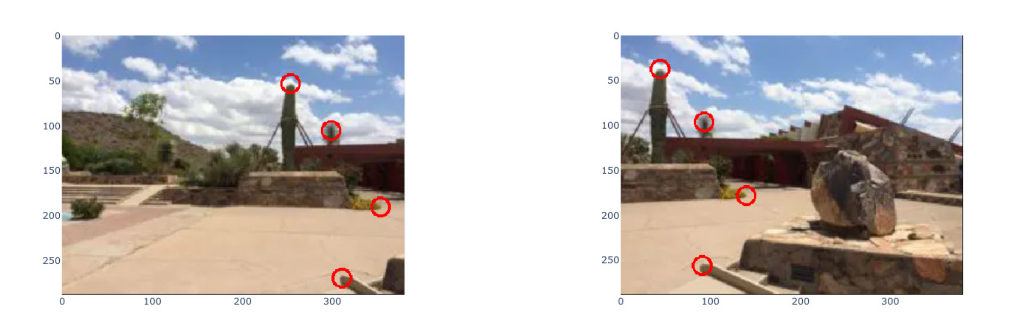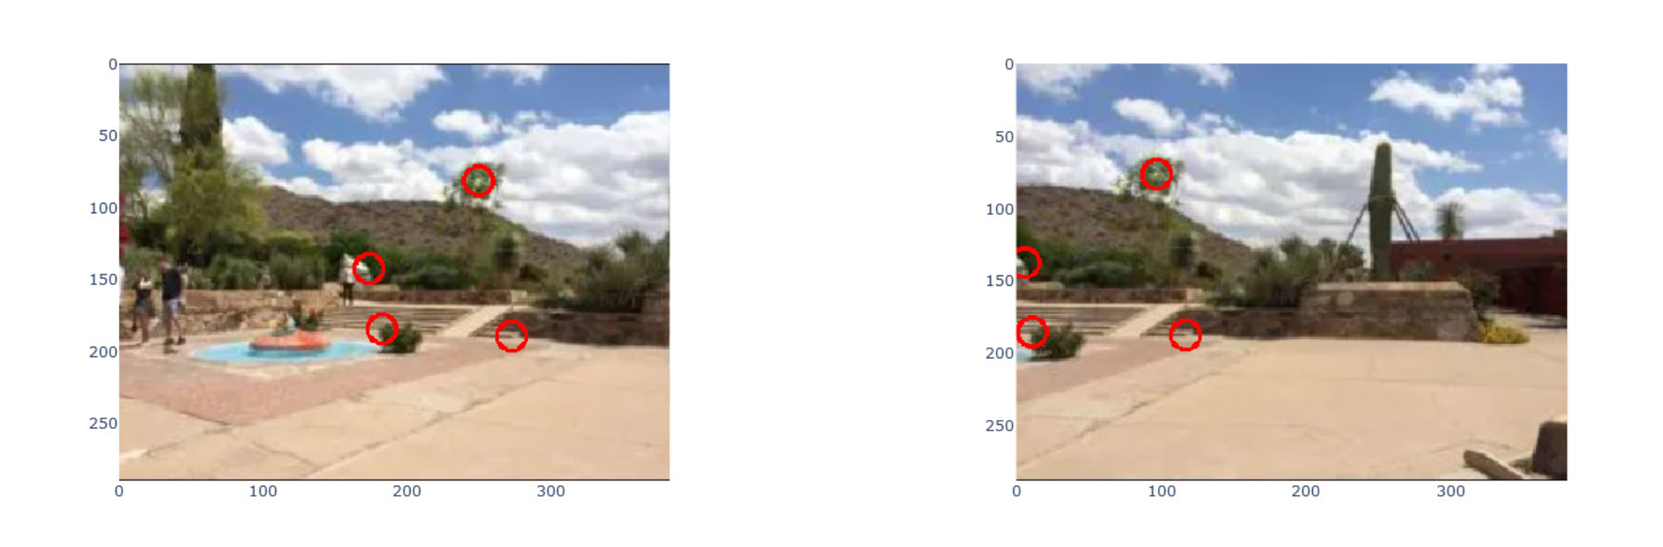

**Stitched Image**

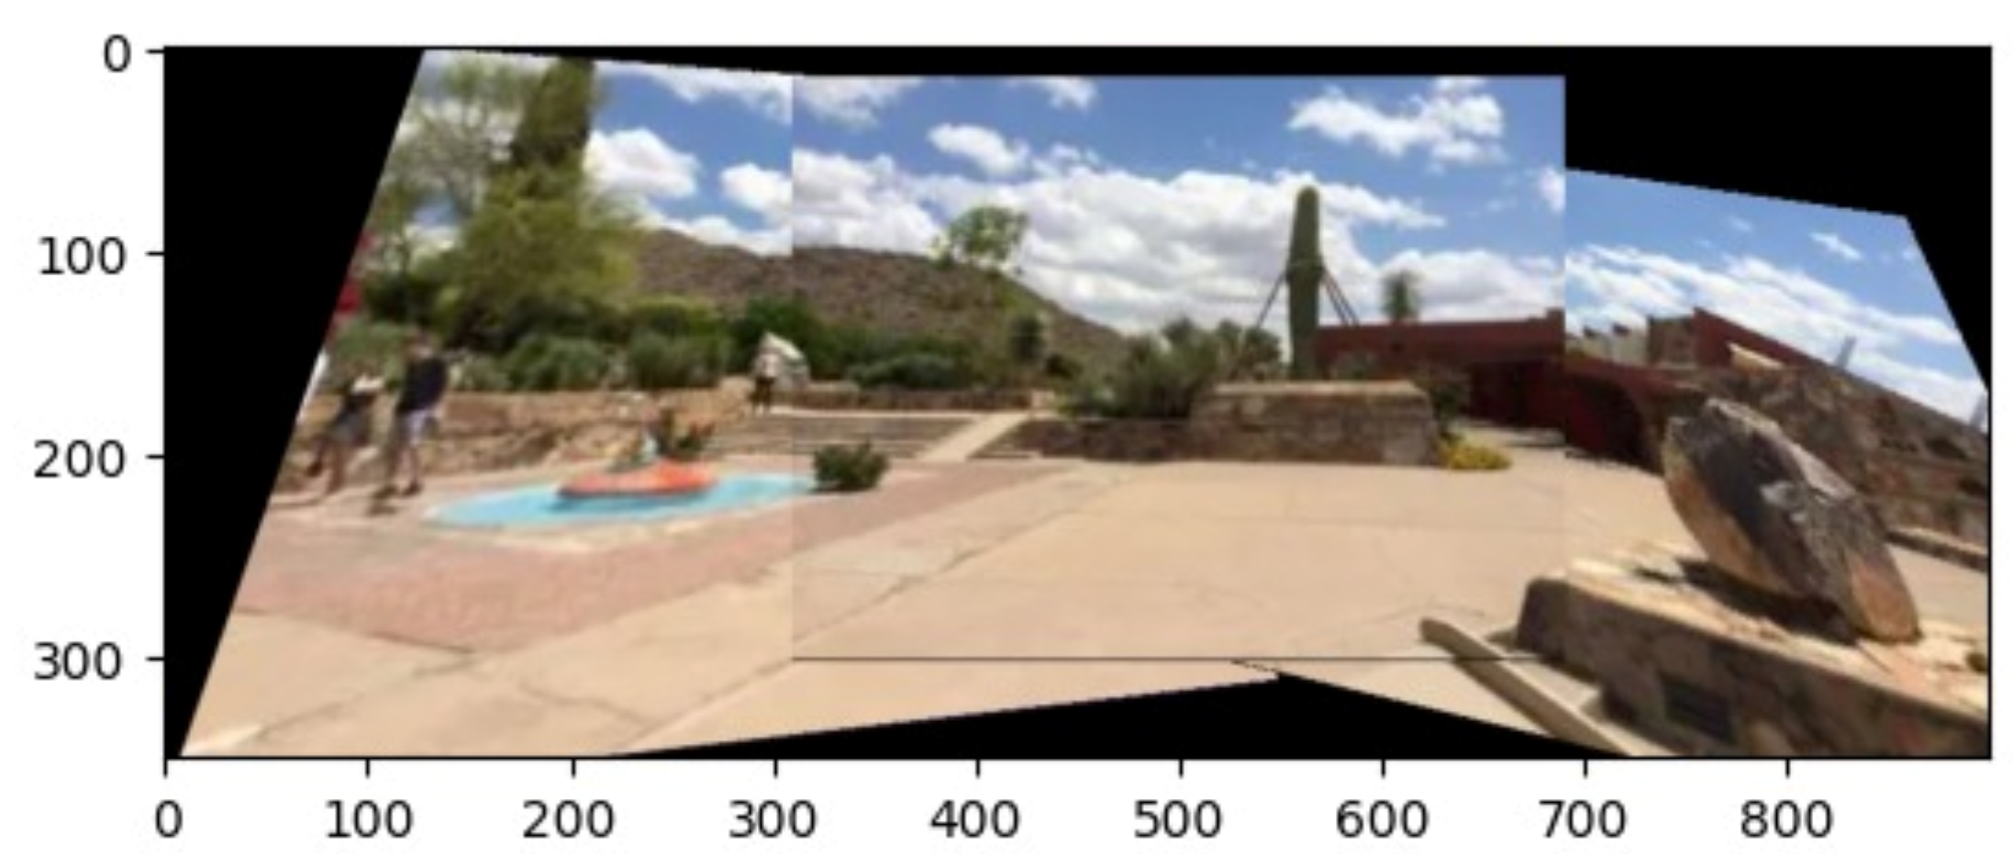

**Bonus Part**  
In this process of stitching three overlapping images, distinct correspondences were manually selected for the left and middle images, as well as for the right and middle images. These correspondences facilitated the computation of homography matrices, denoted as H_left and H_right. The correspondences were visually validated using OpenCV and Plotly Express, where circles were strategically drawn on the left, middle, and right images to mark these identified points.

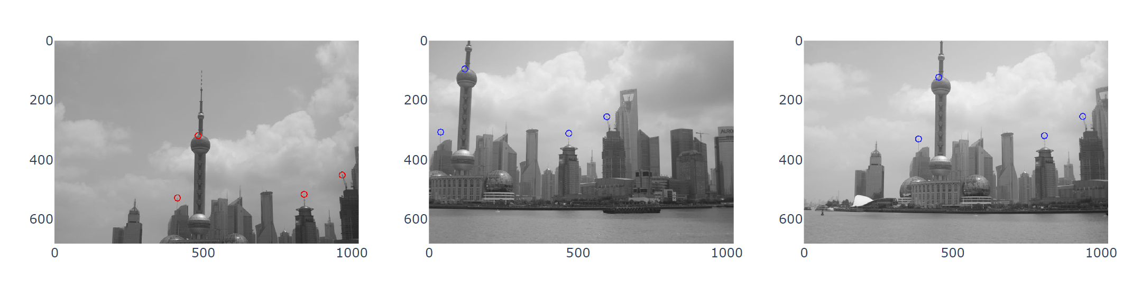

To ensure a seamless stitching process, the dimensions for stitching were meticulously calculated. This involved determining the coordinates of the bounding boxes for both the left and right images. Subsequently, the forward_warp function was employed to execute forward warp transformations, while the inverse_warp function filled any potential holes in the stitched image. The final step involved using the overlay function to merge the stitched image with the middle image.

The resulting stitched image, visualized with Matplotlib, encapsulates all three input images, forming a comprehensive panorama. Notably, the order in which the images were stitched, determined by the homography matrices, played a pivotal role in influencing the final outcome. This underscores the inherent flexibility in achieving diverse panoramic views based on the selected order of stitching.

